Glowtag FD-01 — Round Structure & Scoring
Owns the match timeline, score accrual, the timer and scoreboard UI, and the standings screen.

Round timeline
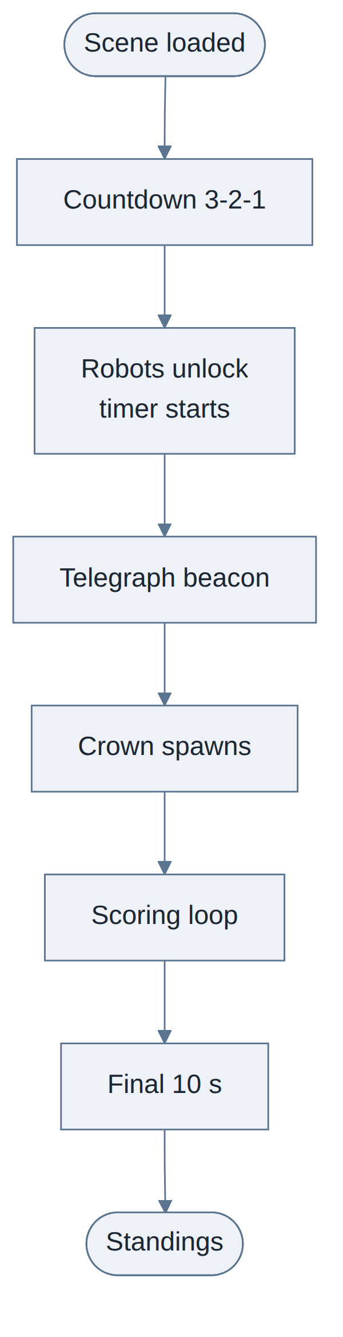
Phase | Length | Notes
Countdown | 3 s | Robots locked, camera free so players can read the arena
Pre-spawn | crown_spawn_delay | Robots driving, Crown does not exist yet
Telegraph | crown_telegraph_duration | Beacon visible. The opening race is already happening
Main round | Remainder | Scoring loop
Standings | — | Final scores and superlatives

Scoring
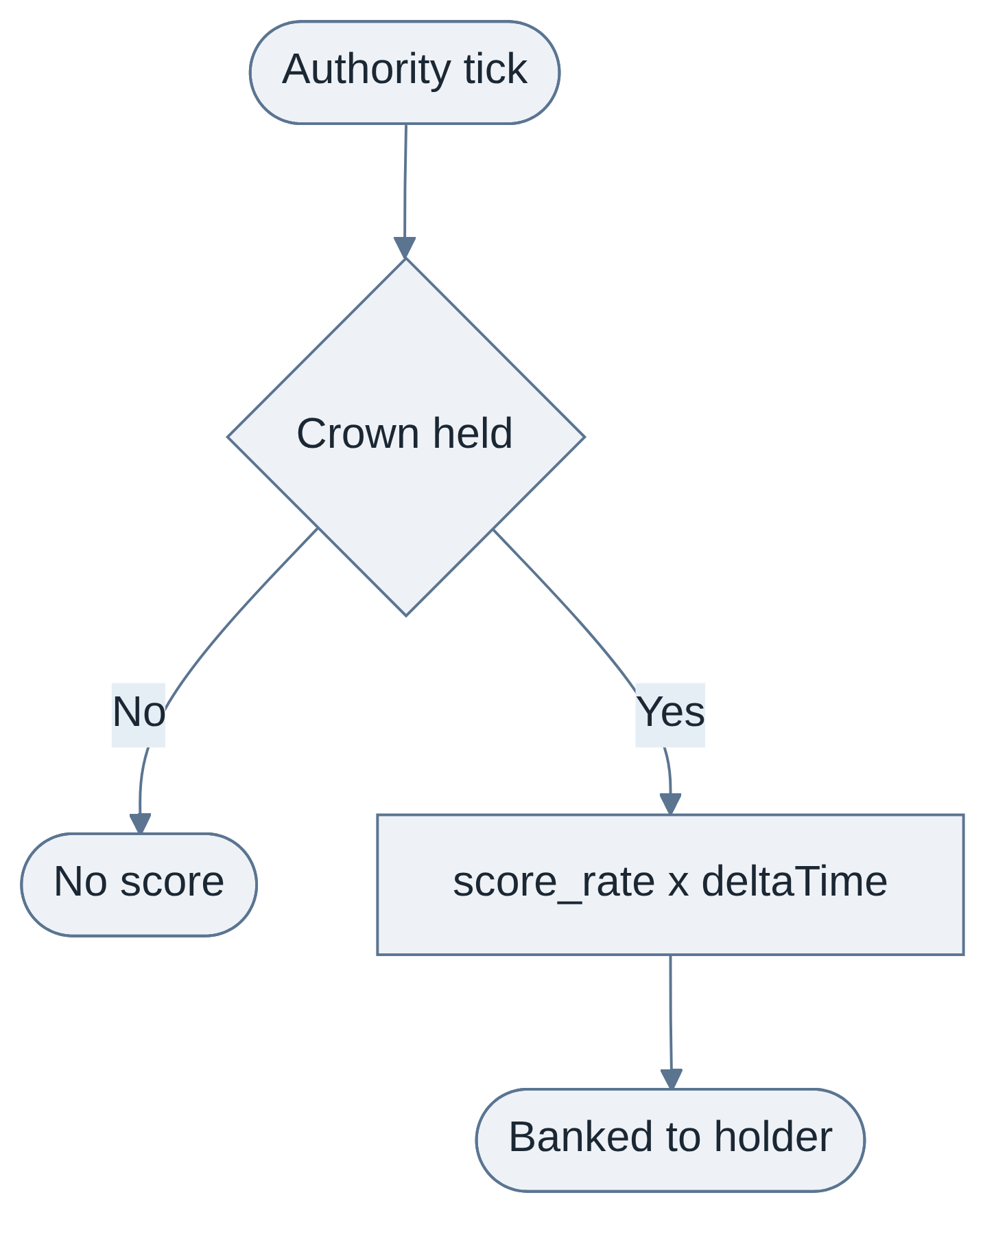
That is the whole model. There are deliberately no multipliers.
Rule | Value | Why
Accrual | Flat score_rate per second while holding | A rate that ramps with hold duration pays the leader for already leading. Flat stays readable — five seconds of holding is always worth five seconds, and players can do the arithmetic mid-round
Banking | Instant, per tick | Losing the Crown costs your income, not your savings. This is what stops the round feeling swingy
Multipliers | None | See the two decisions below

Two levers deliberately not shipped
Both were specified in an earlier draft and cut. They are recorded so their absence reads as a decision rather than an oversight, and so the trigger for revisiting each is written down.
Contest multiplier — cut. This would have paid a holder more for holding near rivals, to stop them driving to an empty corner and circling. The arena is small enough that hiding is not available, so the problem it solves does not exist here. Revisit only if playtests show a holder can meaningfully disengage.
Endgame multiplier — cut. This would have weighted the final fifteen seconds to keep last place driving hard. It was cut because a player can drive an excellent seventy-five seconds and lose to one hit at 0:12, which reads as cheap. Catch-up instead lives entirely in power-up distribution, per FD-04. Revisit only if playtests show rounds being decided well before the end and the power-up weighting failing to close them.
The consequence to watch. With a flat rate and no endgame weighting, all catch-up pressure now rests on the power-up pool. If a round is routinely decided at 0:40 and the last stretch is a formality, the distribution weighting in FD-04 is the first thing to tune, and only then should the endgame multiplier be reconsidered.

Holder speed penalty — not shipping
A small top-speed reduction on the holder would make possession contestable rather than terminal. It is not in v0.1, by decision: the mode should first be felt without it.
It is recorded here because it is now known to be free. Handling Profiles Layer 5 carries transient modifiers, and that document's own worked example is "a flag carrier is slowed for the round." Adding it later is a modifier declaration, not a foundation change. One binding condition applies if it is ever added: "every transient modifier carries a visual state — a null `VisualStateID` fails validation" — which the Crown already satisfies.

UI

Round timer — top centre
State | Treatment
Normal | Large mono digits
Final 10 s | Colour shift and pulse, plus a per-second audio countdown

Scoreboard — top left
One row per player: robot colour swatch, persistent account name, score.
Behaviour | Note
Sort | Live by score. Position swaps animate — the animation is the feedback
Your row | Persistently highlighted
Delta to leader | Shown on every non-leader row, e.g. -140
Ticking | Active accrual shown as motion on the holder's row
Disconnected player | Row greys out, score frozen, stays visible
Bots | Shown under their roster robot's name with no bot marker — the lobby specifies bots are indistinguishable in-match. Only the standings screen labels them

The delta is the most important number on the scoreboard. With no endgame multiplier, it is the only thing telling a trailing player the round is still winnable. A bare score does not do that. Cutting the delta would break Pillar 3.

Standings screen
Final order, then a superlatives row: longest single possession, most steals, most slams landed, most distance driven. All four are cheap — the first three come from Glowtag's own possession events and the foundation's GetLastContactQuality.
They exist so a player who came fifth still leaves with something they were good at, which matters more than the win for this audience. Bots are eligible for them.

Audio
Cue | Trigger
Countdown beeps | 3-2-1 at round start
Score tick pulse | Soft, holder's client only
Final countdown | Last 10 s, per second
End horn | Timer expiry

Tuning
Parameter | Provisional | Range
round_duration | 90 s | 60 to 120
crown_spawn_delay | 3 s | 2 to 5
crown_telegraph_duration | 3 s | 2 to 5
score_rate | 10 pts/s | 5 to 20

score_rate is cosmetic — standings are relative. What matters is that it is flat.

One duration, not a scale
An earlier draft scaled round_duration with player count. That is no longer needed: bots fill every empty slot, so the field is always six and there is nothing to scale against. One value, fixed, not host-selectable.

Edge cases
Case | Handling
A steal resolves on the tick the timer expires | Timer expiry evaluates first. Nothing lands after the buzzer. This must be consistent or final standings get argued about
Tie on final score | Break by total possession time, then by longest single possession. Both already tracked. Show the tie and its resolution on the standings screen rather than resolving it silently
The last real player disconnects | Round ends immediately, standings shown with a note. A field of bots alone is not a match. The lobby document requires each mini-game to rule on this explicitly
A player never touches the Crown | Legitimate. The superlatives row is the mitigation
A player disconnects while holding | See FD-02. Their banked score stays on the standings

Open decision
Endgame multiplier. Cut for v0.1. Reconsider only after the power-up distribution weighting in FD-04 has been tuned and shown insufficient — not before, because two catch-up systems tuned at once cannot be told apart.

